**THE GUIDE TO BUILDING PIECES**

The Building Pieces by PVGames are fairly easy to use for the creation of 2.5D structures. They can be used to map out interiors or can be used to create exteriors (or make maps that utilize both simultaneously for a to-scale persistent world). This guide aims to help people familiarize themselves with the modular pieces.

To begin, let’s see some of the basic types of Building Pieces:

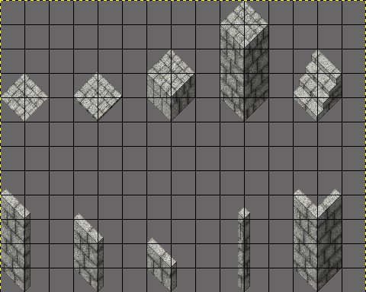

From left to right, top to bottom:

* Lower Floor Tile
* Upper Floor Tile
* Half Column (Column 4)
* Full Column (Column 6)
* Stairs
* Large Wall
* Medium Wall
* Small Wall
* Wall Top Corner
* Wall Bottom Corner

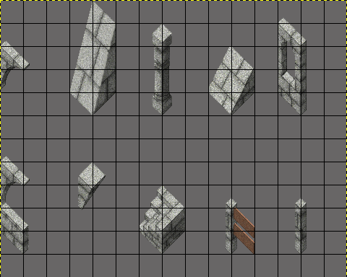

From left to right, top to bottom:

* Archway
* Buttress
* Pillar
* Ramp
* Window
* Wide Window
* Adornment
* Inverted Stairs
* Fence
* Fence Post

Every set of Building Pieces also tends to have some unique shapes and pieces, but the above should cover pretty much the basics.

**Typical Use**

Here you will be shown the typical use and placement of each type of roof tile. For this guide, I will be using GIMP and GIMP settings, but the technique shown here can be used in any image manipulator program that allows for grids and/or grid-snapping. You can also use TileD (this would also work in RPG Maker when the grid is set to 32x32).

The first thing that needs to be done is to create a new blank canvas. For this guide, I am going to use a 480x480 canvas to build a very small house. When you have your blank canvas open, toggle “Show Grid” to on, under the “View” tab and then under the “Images” tab, select “Configure Grid” and set the “Spacing” to 32 for both horizontal and vertical:

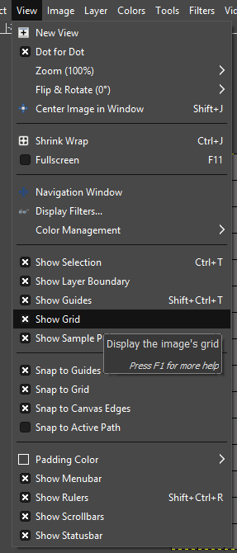 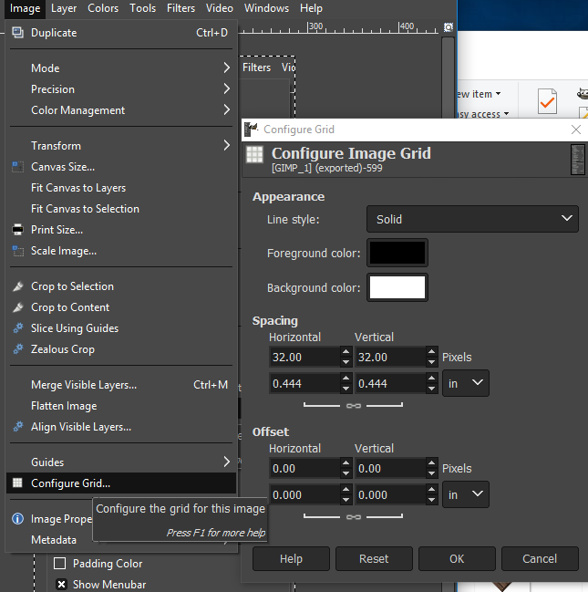

Be sure to also click to enable “Snap to Grid” under the “View” tab. Now you have a snappable 32x32 grid!

Now that we have our grid set up, we can begin building our structure! For this demonstration, this building will be somewhat simplified.

I generally recommend starting with the floor first and map out the layout of the room/building.

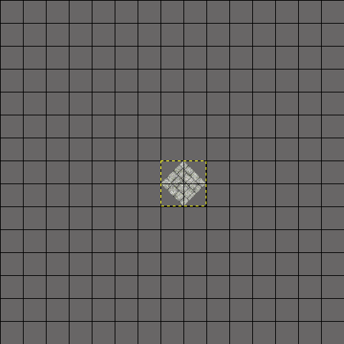

To begin, use the Lower Floor tile pieces. The Upper Floor tile pieces are for, well, the upper floors! The difference between the two is that the Upper Floor tiles have a small edge to them that give them a slight boost in height. Of course, if you really wanted to, you can use any of the floor tiles (or even the column tiles) to lay out your floor with various visual effects. Experiment and have fun! But for now, I will stick with the Lower Floor tiles.

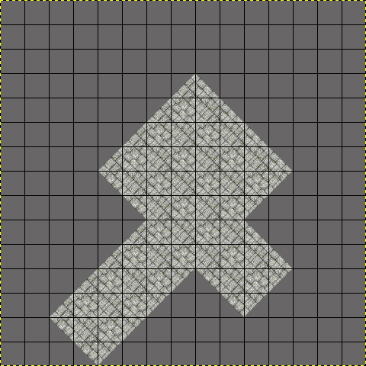

And here to the left I have finished mapping out the layout of my building using just the floor tiles. This gives me a solid blueprint and an understanding as to where each of the various Building Pieces will ultimately be placed.

Next I will begin building the walls. It is best to begin at the top-most (North) point and work your way down towards the bottom-most (South) point due to how the pieces overlap.

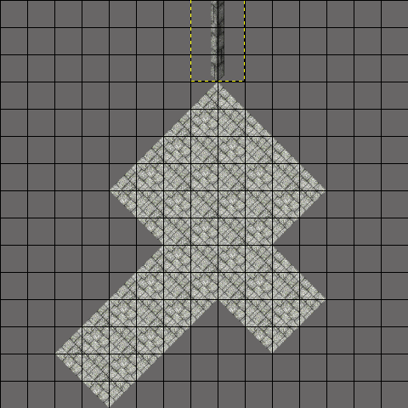

The first piece should be the Northern-most corner post (typically Wall_Large_6 for regular walls).

Note the placement of this piece, it does not overlap the ground tiles, but sits directly adjacent/atop them, bordering without any overlap.

The next part of the process will add the two wall facings moving along the Northeast and Northwest edges.

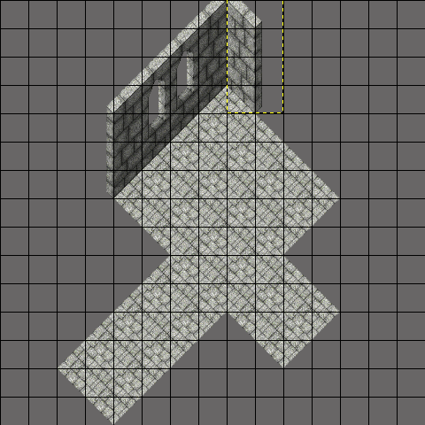

Just like the center post on the Northern most point, each wall segment along the Northwest and Northeast edges do not overlap the floor, but sit directly adjacent to it. The walls will overlap one another slightly, hiding the shortened edge of the wall.

It’s generally a good idea to mix window walls with regular walls to give variety, though if you have specific designs in mind for décor, naturally go with what will bring your ideas to fruition.

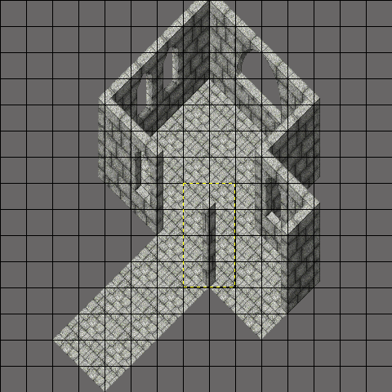Next we finish up the Northeast and Northwest walls and add in the Southwest and Southeast walls. Whenever you have a junction in the building such as the one in this example, you will need to utilize another corner post wall piece.

Here we see the placement of the Northern corner piece at the junction in the building. The opposite side does not require one.

*\*A note regarding best practices: If you are using a program that allows for different layers, then it is HIGHLY recommended that you have the Southwest and Southeast walls on a different, higher layer than the Northeast and Northwest walls. This will allow you to easily add objects and furniture to the room that might otherwise be partially obfuscated by the walls. Further, this allows you to import the maps into your game-making software in layers and you can have it so that the player can move behind these walls in a more realistic fashion.*

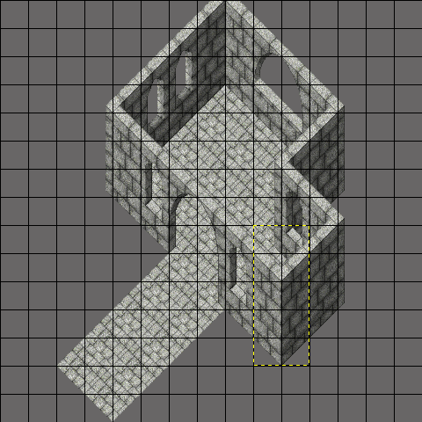

With the corner in place at the junction, we now treat the remainder of the wall as we would in the beginning by laying out the rest of the wall pieces.

Here we see the placement of the South corner wall. Whenever a South-facing corner of a building needs to be closed off, you need to use the South corner wall (typically Wall_Large_5).

In this picture you can also note that I opted to use archways for the end of the hall. These were placed just like the wall pieces, and in this specific case, I replaced the North corner piece with one of the archway pieces.

And lastly, we finish off the rest of the entrance hall with basic wall pieces, working from the highest point to the lowest point of the screen:

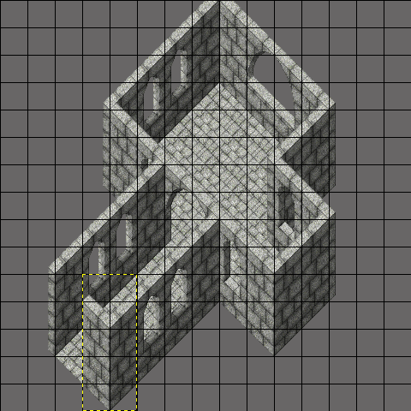

For this building, a gap is left where the door would be placed. And that’s it, the building’s walls and floor are complete! To add a roof, see the Roof Tile Guide.

Of course, you can add all sorts of adornments and visual flair with various other Building Pieces:

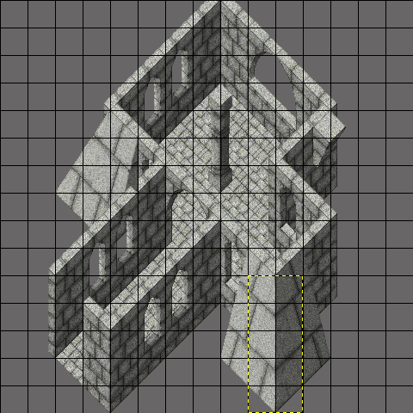

**Stairs and Ramps**

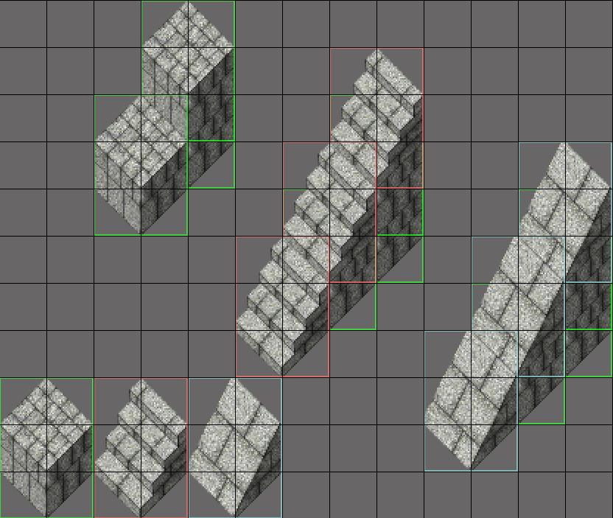

Using the Half Column (Column_4) and the various Stair and Ramp pieces, you can make stairs and ramps of all sizes, shapes, and directional facings. Typically, two of the Half Columns stacked (or one of the Full Columns, Column_6) with stairs stacked on top will reach the top of a regular-sized wall. Using a Half Column adjacent to the Full Column or double Half Column stack will allow you to place a Stair or Ramp piece that will connect together with the higher and lower pieces (and ultimately to the floor).

In the end, the modular Building Pieces are very flexible and similar to Lego building blocks. You can get very creative and come up with all sorts of interesting combinations and structures. The best thing you can do is play with the pieces and experiment and have fun!